Solo Project :

The wireframe :

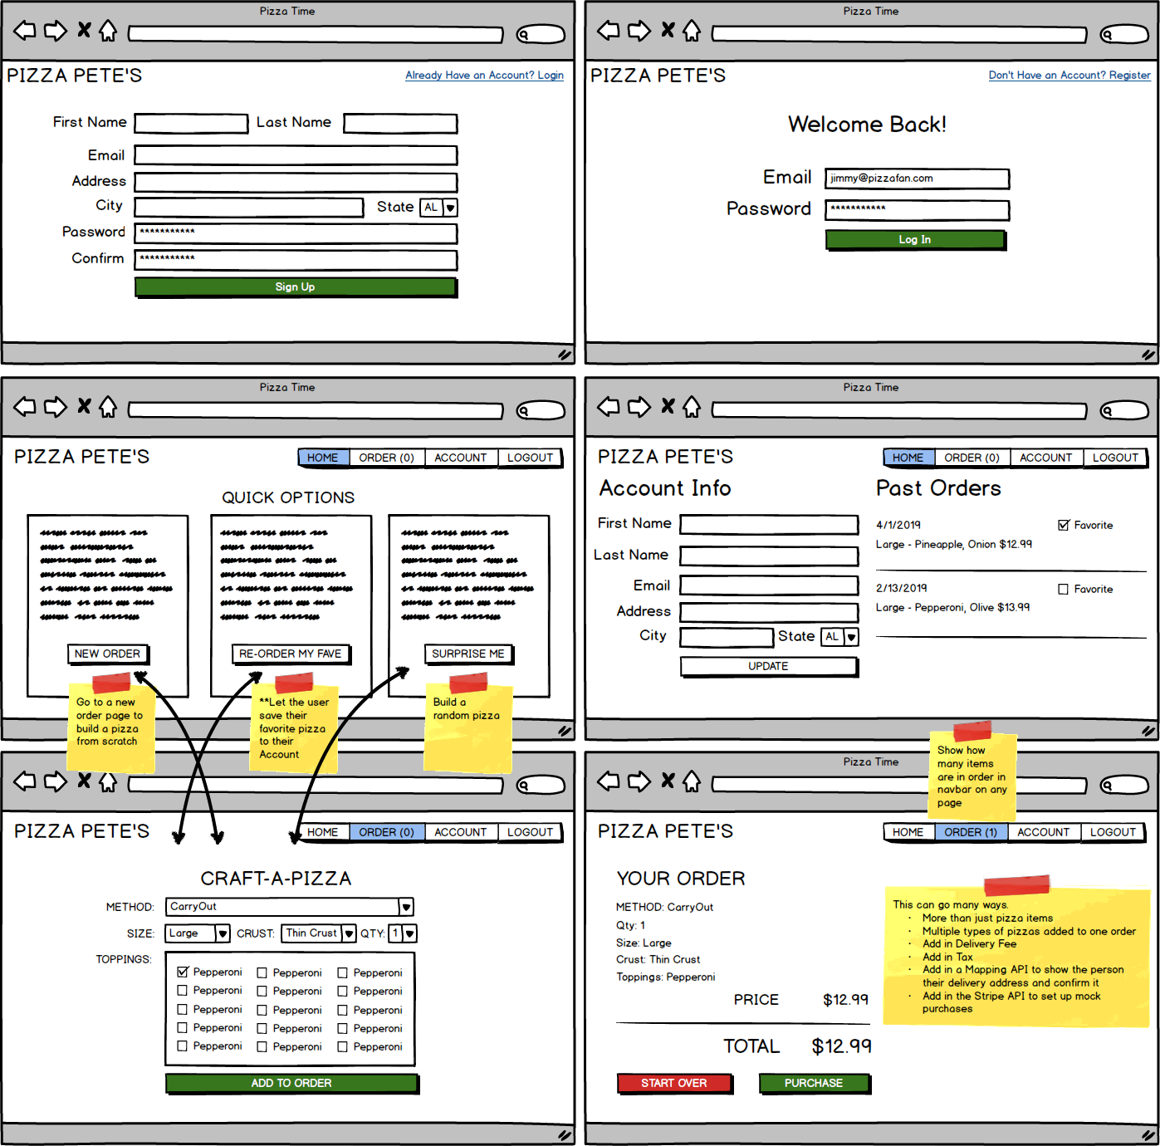

Project Name: Pizza Time,

The Technologies: MERN.js,

The GitHub repository: <https://github.com/dridiabyr/codingdojo2>,